**NAXT Quick tips**

**FREIGHT ESTIMATES when part quantities are increased**

Family A is really disorganised and has to make 3 round trips to the camping ground to bring all their things. Family B does it all in one go. Both families bring the same amount of things.

*Which family pays the most for fuel costs?*

|  |  |
| --- | --- |
| **A: Take 3 round trips to the camping ground** | **B: Take all the luggage in one go** |
|  |  |

**ANSWER – A!** 3 trips will cost more than 1.

The same goes for the freight estimator.

If you change your mind and need 3 parts instead of one, DON’T change the qty of the part – that will mean your 1 freight (trip) will be multiplied by 3!

**To estimate the correct freight follow these steps:**

1. **Remove the freight line**
2. **Change the part quantity**
3. **Use the freight estimator again**
4. **The freight we charge the customer will be much cheaper.**

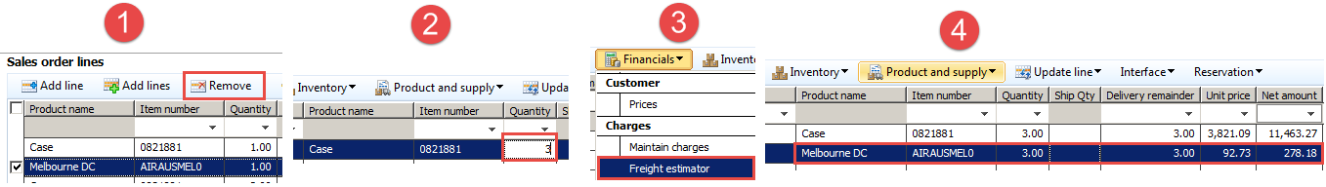

**Compare the freight estimates below:**

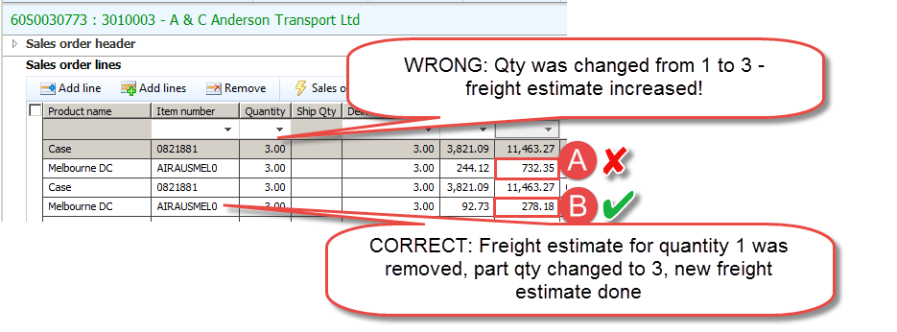

**See SOP for how to use the Freight Estimator** [**PRT_5.4(SOP)Recover Freight**](http://intra/files/prt-5-4-sop-recover-freight---may-2016-pdf-gnAzU9.pdf)